Digital Image Processing

Assignment 2  
23/4/2021

Submitted by -:

Kshitij Chhabra 2017A8PS0691G



**Question 1**

Take a picture of a page with printed text. Use MATLAB’s “ocr” package to recognize the text and save the content as .txt. Display output image with word bounding boxes and recognition confidences. (Save code as Q1.m)

For the following input image-:

This input image is from a chapter heading of an international bestseller - “The Psychology of Money” by Morgan Housel

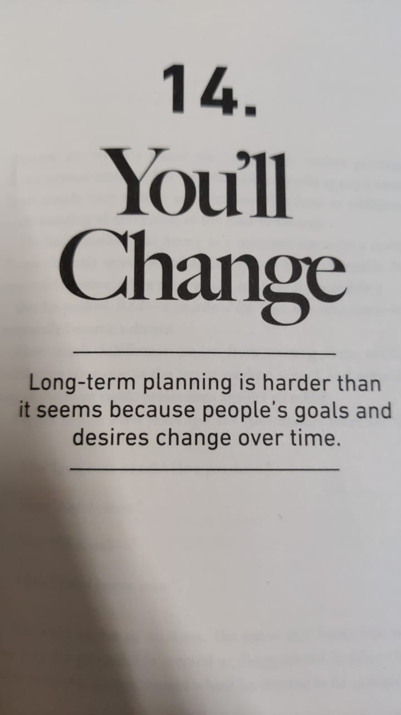

The following code was run-:

% Reading the Image

input_image = imread('inputQ1.jpeg');

% Using MATLAB's OCR function to get ocrResults

ocrResults = ocr(input_image);

% Inserting Annotations

Iocr = insertObjectAnnotation(input_image, 'rectangle',ocrResults.WordBoundingBoxes,ocrResults.WordConfidences,'FontSize',20);

% Plotting the output

figure; imshow(Iocr);

% Saving the image output

imwrite(Iocr,'output image Q1.png');

% Saving the results in a text file

filehan=fopen('Text.txt','w');

fwrite(filehan,ocrResults.Text);

fclose(filehan);

The results were stored as-:

output image Q1.png

Text.txt

The output image is shown as-:

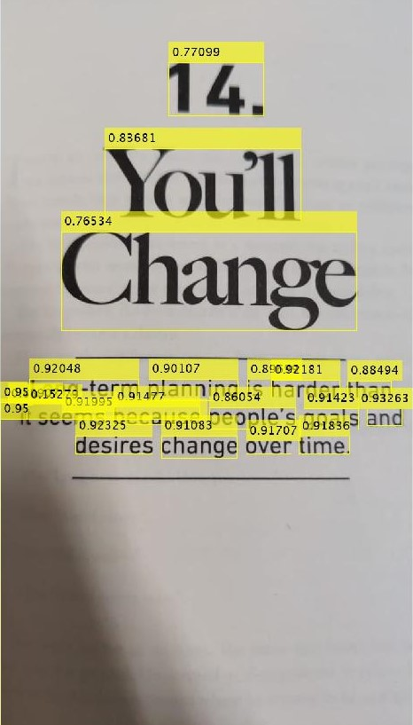

Observations-:

* Although most of the words were recognized with detected, the recognition only worked for a certain level of confidence with certain characters being recognized as non-english symbols.
* The average word confidence was 85.96%
* The MATLAB OCR library doesn’t work very well for non planer text images.
* While testing out different pages, it was observed that even lines ( ----- ) get detected at times but with zero confidence.
* Certain characters on the left corner were misinterpreted because of poor lighting conditions.
* Even punctuations such as . and exclamation marks get detected

Example 2

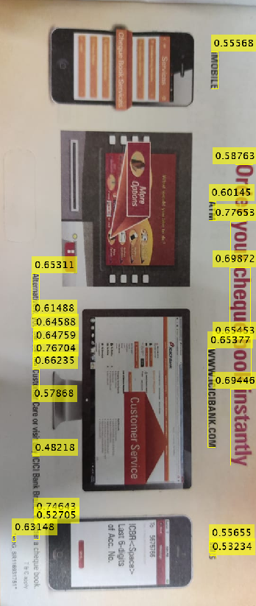

Learnings-:

* Text in images were detected better but the recognition system gave stray values.

The final conclusion that can be observed is that the detection function of ocr library work really well but the recognition based purely on image processing techniques may give us a slightly astray result

**Question 3**

Read the attached paper “Artistic Style Transfer”, and using their code (github link given in the paper) transform your selected image to the style of “Starry night”. No need to save code. Show input images and outputs.

Input and Output Images -:

The artistic style transform was performed on 400 x 400 (72dpi) image of the 14th prime minister of the biggest democracy in the world: Mr. Narendra Damodardas Modi.

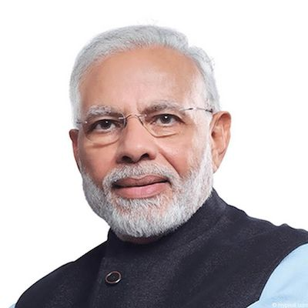

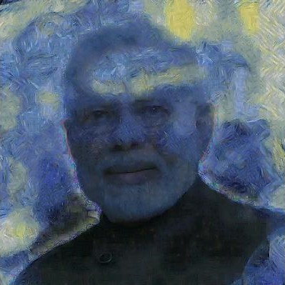

Sample Images 2-:

The second set of images depict the milky way galaxy and is a stock image taken from google. Starry night transform was applied to it.

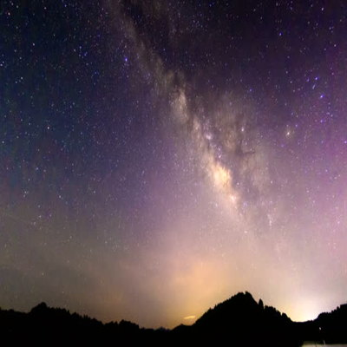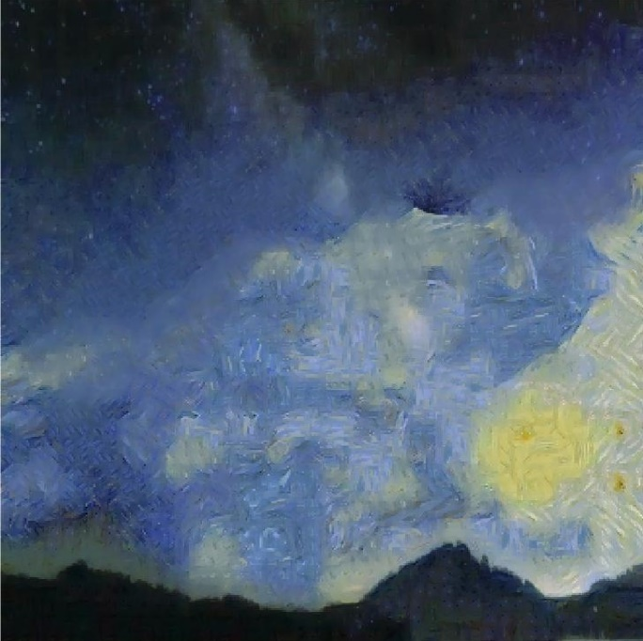

**Learnings-:**

* This paper achieves an artistic style transfer by purely using image processing paradigms in contrast to previous work which utilized DNN
* The algorithm has six main steps-: style fusion, patch matching, style synthesis, content fusion, color transfer, and denoising.
* All the images to be processed in this code are assumed and required to be 400*400
* Gaussian noise is added in the preprocessing step to allow the patch matching step make more venturous guesses.
* In order to maximize the variability in the style transferred a weighted average between the estimated image and a hallucinated image is applied in each iteration.
* To ensure that the original content is preserved, a pixel-by-pixel weighted average of the content image and the estimated style image is performed.
* One case where this algorithm does not produce pleasing results is when the style image does not provide a good representation of the style.